**Kural**

Kural logo

The voice of wrights

Start up under SHRI, DST

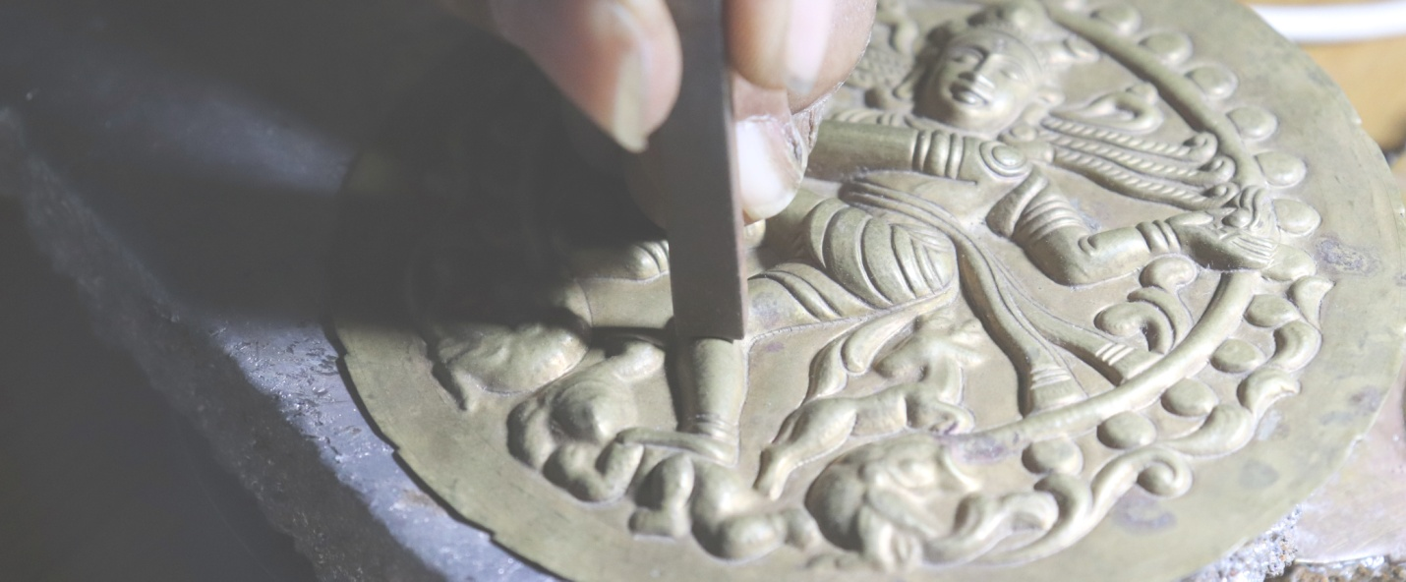

Concoction of Heritage and Tech to voice out the unsung craftsmen

**School of design**A platform to deliver design knowledge without missing nooks & corners

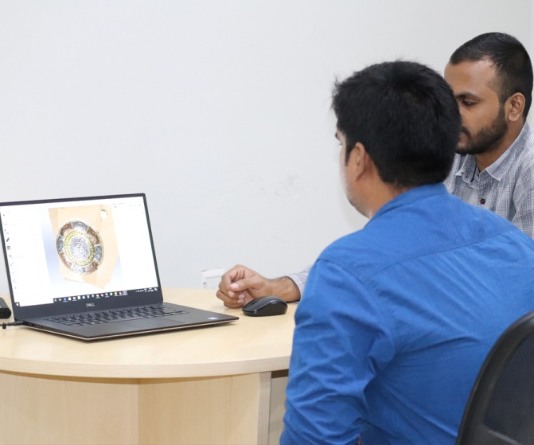

**Innovative heritage products**Unveiling contemporary products to bring in the spotlight the artisans deserve.

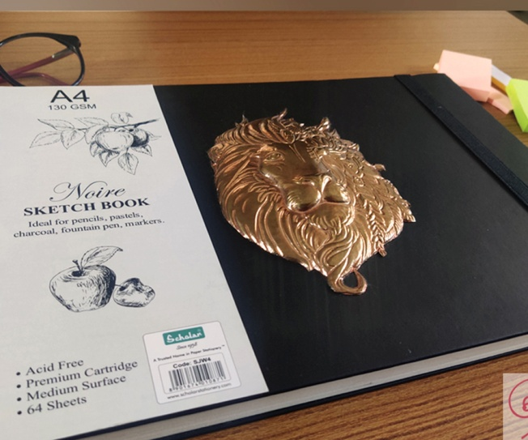

**Ergonomic furniture**Shape adaptive furniture with comfort and health as utmost aim

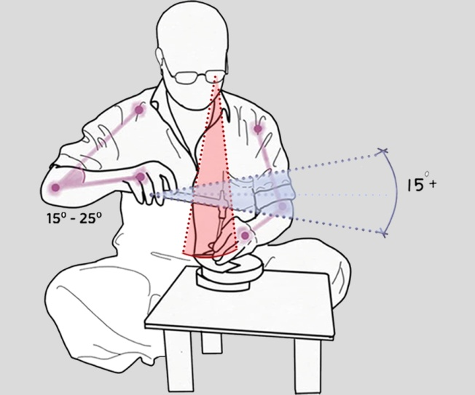

**Ethnic series**Incarnation of existing roots to light up the interior world

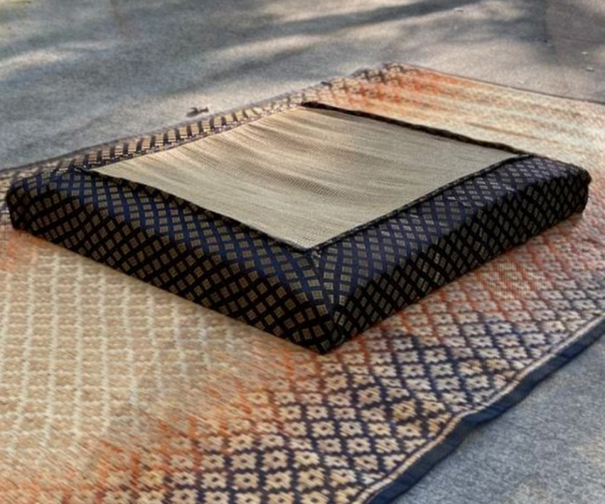

**Testimonials**

What people say about us

**About the crafts**

**(scroll)**

**Thanjavur Art plate**

‘Mélange of metals tracing its roots’

Art plate is a cultural heritage craft confined to the city of Thanjavur. It is an eminent art of etching, embossing and engraving metals to deliver a fabulous art piece.

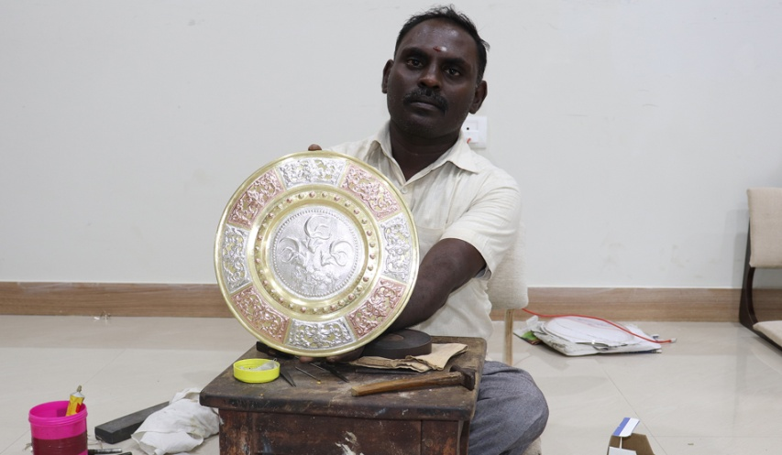

**Swamimalai Bronze icons**

‘Chisel crafted idols engraved to fineness’

Swamimalai icons are commonly called Panchaloha statues, made using the ancient lost wax technique. Utsavar icons taken for procession are from the hands of the Stapathis.

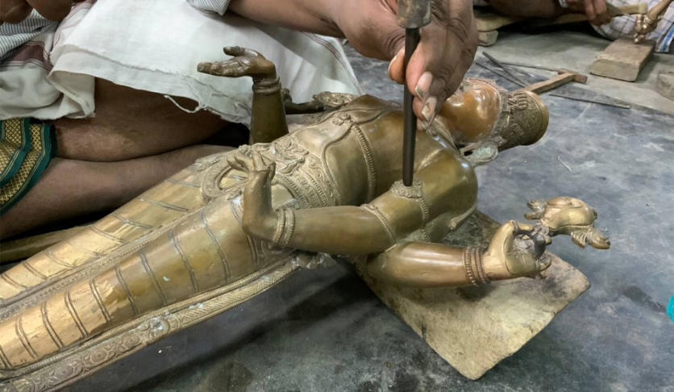

**Ayyampettai Kutni**

‘Woven art piece with the language of its own’

Kutni fabric is a double sided fabric with cotton touching the body and silk in the outer side. Glossy surface, rich colors and appealing patterns are the traits of Kutni.

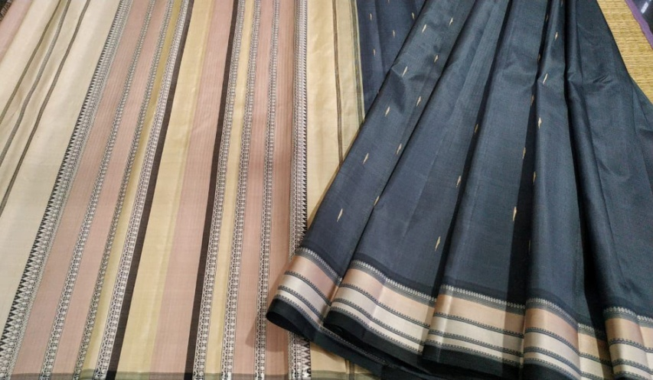

**Pattamadai Mats**

‘It’s not the length of life but the depth of life’

The hand-woven korai mats is a traditional craft of Pattamadai region. These mats are commonly called Kalyana paai and known for quality and finesse. The fine mats and silk mats adds comfort and has good thermal properties.

